UNIFIELD – Memo

Load tests

Author: Grégory Bellier
Date: 24.07.2012
Revision: 7
Status: Validated

UNIFIELD – Memo 1
Load tests 1
1 Introduction 2
2 Definition of the testing environment 2
2.1 Synchronization server hardware 2
2.2 JMeter machines 3
2.3 Protocol 3
2.4 Synchronization server monitoring 3
3 Tests environments 3
3.1 Laboratory 3
3.2 Degraded network 4
3.3 OVH 5
4 Test sizing 5
4.1 Sizing 5
5 Tests scenarios and validation criteria 6
5.1 Mass update of master data 6
5.2 Regular / day to day processes 7
5.3 Monthly process 8
6 Planning 8

Introduction
The main goal of the load tests is to determine if the architecture of the synchronization server is robust enough to handle the workload induced by the instances in real conditions.
The tests results will be a reference results that will be later compared to future Unifield release candidates.
Neither the instances nor functional tests are the goal of these tests.

Definition of the testing environment
As we won’t be able to test with hundreds of installations, the only way is to generate volumes and measure the performance using dedicated tools such as JMeter. JMeter will act as a replacement of local instances on field.
There is only one synchronization server.

Synchronization server hardware
For the implementation of the test, the server will have the following configuration:
- Dell PowerEdge R620
- Memory: 64 GB, (8 × 8 GB) at 1333Mhz
- CPU: Intel Xeon E5-2643, 4 × 3.3 Ghz, 10MB cache
- 4 Hard drives and 1 hardware-raid card (PERC H310):
  - Raid-0: 2 HDDs (300 GB, SAS, 15k rpm) => system (/ formatted in ext4)
  - Raid-0: 2 HDDs (300 GB, SAS, 15k rpm) => PostgreSQL databases (/var formatted in ext4)
- Broadcom NetXtreme BCM 5720 Gigabits Ethernet 4 ports (only one will be used)
- OS: Ubuntu Server 10.04 LTS 64 Bits

This configuration is based mostly on performance and not on data security but with the final target in mind. This will help to evaluate the kind of configuration required to run the synchronization server.
OpenERP and the PostGreSQL databases require a lot of memory.
In terms of pure performance, cache memory built into the CPU is faster than RAM which is faster than hard drives.
That’s why the CPU must have the highest memory cache possible. It’s the same reasoning for the RAM (Memory). The more data stored into the RAM the lesser hard drives are accessed. The RAM bandwidth must be the highest possible to transfer data as fast as possible.
Hard drive accesses cannot be avoided but to speed up the writing and reading accesses, a raid-0 solution must be put in place. A raid-0 could be achieved by software but it is better performed with a dedicated hardware card.
Although SSDs are faster than HDDs, they would not live long due to the IO induced by PostGreSQL. That’s why 15k rpm hard drives were chosen.
In the version 6.0 of OpenERP, it is not multiprocessed which means that a higher frequency for each core is better than a lower frequency with more cores. However OpenERP is not the only software to run and software such as PostGreSQL could benefit from having several cores. The safest choice is to have at least 4 cores with a high frequency.
2 different network cards should be used for redundancy. But for these tests, a Gigabit Ethernet card is enough.

JMeter machines
5 physical machines simulate the behaviour of local instance servers driven by a master node which is a 6th physical machine. Those machines are lent by OCG and are standard ones:
- HP Compaq 8200 Elite Ultra-Slim desktop

Protocol
XML-RPC is the greediest protocol, that’s why it was chosen.

Synchronization server monitoring
Although OpenERP provides some basic monitoring informations regarding the application, it cannot monitor the system as it is a completely different scope.
The monitoring will be performed by Munin.

Tests environments

Laboratory
In laboratory conditions, the network must have the best conditions (highest bandwidth, almost none packet loss, lowest latency) to induce the highest workload on the server.

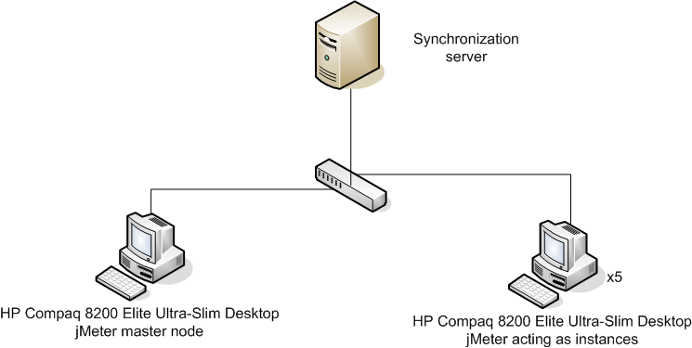
Fig 1. Best possible network conditions

This environment will validate the test technically, to ensure that the following test corresponding to actual conditions do not fail because of problems in the construction of the test itself.

Degraded network
The objectives of these tests are to be close to the worst conditions as measured on field by the OCs when they established the site-mapping.

Download (in Mbps) | Upload  (in Mbps) | Packet loss  (%) | Latency  (ms) | Criteria
2.00 | 0.06 | 0.00 | 2055.67 | Highest latency
0.06 | 0.03 | 0.13 | 914.33 | Lowest download/upload bandwidth
0.27 | 2.46 | 3.00 | 155.67 | Highest packet loss

The average measures as reported in the site-mapping:
Download (in Mbps) | Upload  (in Mbps) | Packet loss  (%) | Latency  (ms) | Criteria
0.62 | 0.29 | 0.01 | 560 | Average measures

The network degradation will be done with Wanem, a tool already used for the PoC. It is not possible to dedicate a part of the bandwidth to download or upload.
Wanem will be configured with a common bandwidth for download and upload.
The following conditions will be tested:
Bandwidth  (in Mbps) | Packet loss (%) | Latency (ms) | Criteria
2.00 | 0.00 | 2100 | Highest latency
0.06 | 0.13 | 900 | Close to the average conditions
2.5 | 3.00 | 150 | Highest packet loss

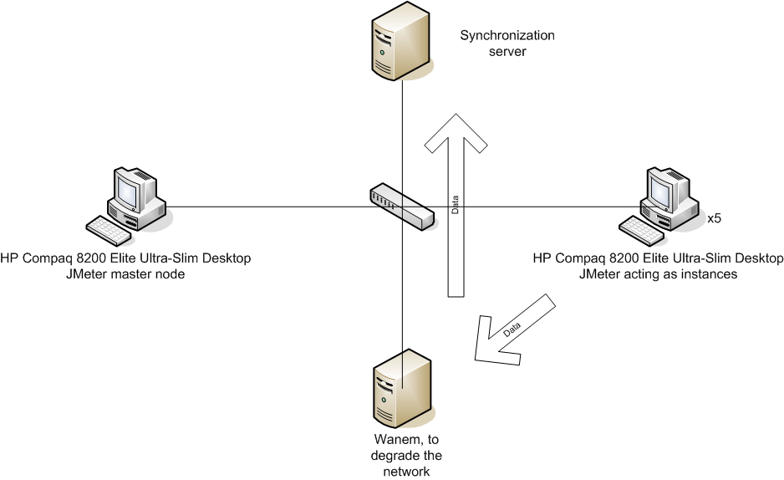
Fig 2. Degraded conditions with Wanem

OVH
This test will be conducted on the same basis than the laboratory, except that the synchronization server is another one hosted (OVH Hardware) at OVH. This test can be influenced by the nodes between the instances and the server such as firewalls and routers.

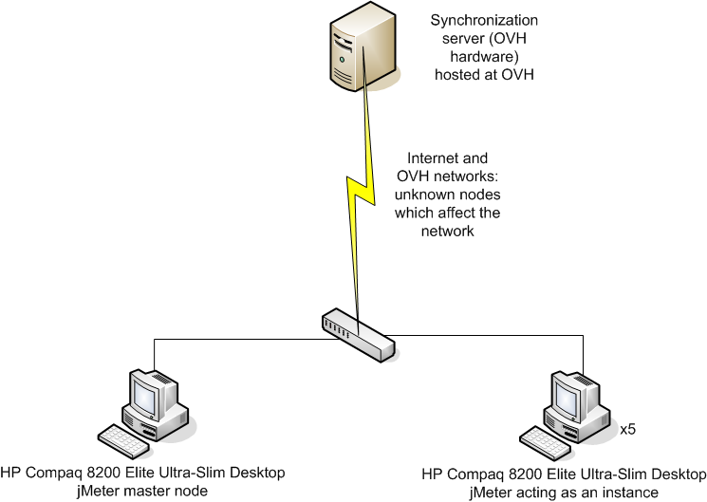
Fig 3. Synchronization server somewhere in the cloud

The synchronization server hosted at OVH has the following configuration:
- CPU: Intel Xeon E5504, 4 × 2.00 Ghz, 4 MB cache
- RAM: 24 GB

Test sizing
All tests are performed in the three environments described in the previous paragraph.

Sizing
The tests will be conducted with:
- 5 OCs
- 105 coordinations
- 270 projects
declared into the database.

The max_size will be set to 500. It means that each packet can contain up to 500 elements (for example: products) as long as the same rule applies to all.

The tests scenarios will be performed with an empty database unless a test scenario depends on another one.

Tests scenarios and validation criteria
Every single test implies the whole synchronization (pull data, pull message, push data, push message)

Mass update of master data
- TS_1: Sending updates of the ITC item database from the OC instances to the synchronization server
  - Conditions:
    - 7000 updates / OC
    - 5 OCs simultaneously
  - Validation criteria:
    - Time of execution: < 30 minutes

- TS_2: Sending updates of the ITC item database from the synchronization server to the coordination instances
  - Conditions:
    - Each instance pulls the items sent by its OC at TS_1
    - 40 coordination instances simultaneously
  - Validation criteria:
    - Time of execution: < 1 hour

- TS_3: Sending of FX rates from the OC instances to the synchronization server
  - Conditions:
    - 159 currencies / OC
    - 5 OCs simultaneously
  - Validation criteria:
    - Time of execution: < 5 minutes

- TS_4: Sending of monthly FX rates from the synchronization server to the coordination instances
  - Conditions:
    - Each instance pulls the FX rates sent by its OC at TS_3
    - 40 coordination instances simultaneously
  - Validation criteria:
    - Time of execution: < 5 minutes

Regular / day to day processes
- TS_5: Sending of POs creations from the project instances to the synchronization server
  - Conditions:
    - 4 POs / OC
    - 60 project instances simultaneously
  - Validation criteria:
    - Time of execution: < 5 minutes

- TS_6: Sending of FOs creations from the synchronization server to the coordination instances
  - Conditions:
    - Coordination instances pull respectively the PO created at TS_5 by the Project instances
    - 20 coordination instances simultaneously
  - Validation criteria:
    - Time of execution: < 5 minutes

- TS_7: Sending of accounting lines from the coordination instances to the synchronization server
  - Conditions:
    - 18 accounting lines / instance
    - 40 coordination instances simultaneously
  - Validation criteria:
    - Time of execution: < 5 minutes

- TS_8: Sending of analytic lines from the coordination instances to the synchronization server
  - Conditions:
    - 28 analytic lines / instance
    - 40 coordination instances simultaneously
  - Validation criteria:
    - Time of execution: < 5 minutes

If enough time:
- TS_9: Sending of registers lines from the coordination instances to the synchronization server
  - Conditions:
    - 22 register lines / instance
    - 40 coordination instances simultaneously
  - Validation criteria:
    - Time of execution: < 5 minutes

Monthly process
- TS_10: Sending of newly created registers from the project instances to the synchronization server
  - Conditions:
    - 6 registers / instance
    - 60 project instances simultaneously
  - Validation criteria:
    - Time of execution: < 5 minutes

- TS_11: Sending of newly created registers from the synchronization server to the coordination instances
  - Conditions:
    - Coordination instances pull the newly created registers at TS_10
    - 20 coordination instances simultaneously
  - Validation criteria:
    - Time of execution: < 5 minutes

Planning
From 20/06 to 22/06: JMeter training
From 25/06 to 23/07: load tests preparation of scripts and XML files to simulate instances
From 11/07 to 23/07: first internal load tests
From 25/07 to 27/07: load test campaign in presence of referents of the ITWG

